**EXPERIMENT NO:-4**

* **AIM**: To design and test Half / Full adder and Subtractor circuits.
* **APPARATUS:** IC 7404, IC 7408, IC 7432, IC 7486, connecting wires, LEDs.

* **THEORY:**

Digital computers perform variety of information processing task. Among the basic functions encountered are the various types of arithmetic operations. Here we will see how these operations can be performed using digital hardware.

➢ **Full Subtractor**: This Subtractor subtracts binary digits along with borrow from the previous stage. The outputs of the Subtractor are difference and borrow out.

CRCUIT DIAGRAM OF FULL SUBTRACTOR:

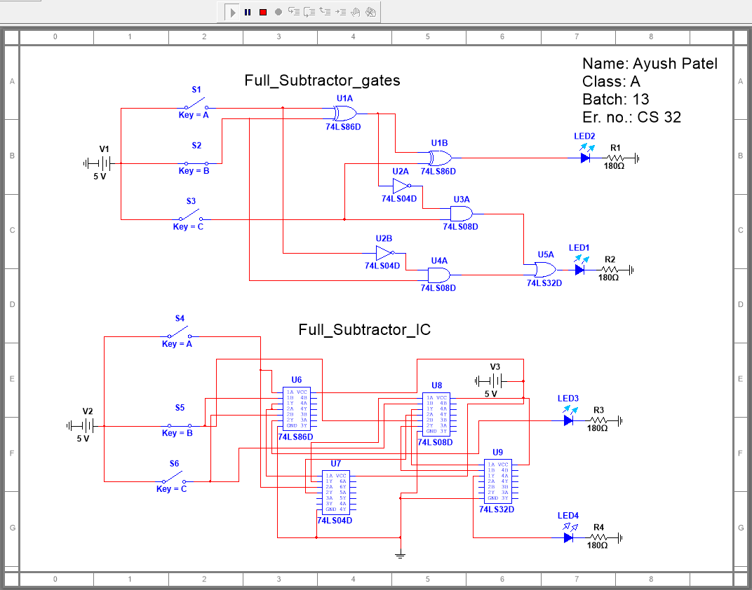

TRUTH TABLE:

# FULL SUTRACTOR

|  |  |  |  |  |
| --- | --- | --- | --- | --- |
| **A** | **B** | **Bi** | **D** | **Bo** |
| **0** | **0** | **0** | **0** | **0** |
| **0** | **0** | **1** | **1** | **1** |
| **0** | **1** | **0** | **1** | **1** |
| **0** | **1** | **1** | **0** | **1** |
| **1** | **0** | **0** | **1** | **0** |
| **1** | **0** | **1** | **0** | **0** |
| **1** | **1** | **0** | **0** | **0** |
| **1** | **1** | **1** | **1** | **1** |

Expression for Difference and Borrow Out:

D= 



Bo=

➢ **Half adder:**  The adder adds only two bits and carries from the previous stage will not be added. The outputs of the adder and are SUM and CARRY. Truth table of half adder is given below.

CIRCUIT DIAGRAM OF HALF ADDER:

TRUTH TABLE:

# HALF ADDER

|  |  |  |  |
| --- | --- | --- | --- |
| **A** | **B** | **S** | **C** |
|  |  |  |  |
|  |  |  |  |
|  |  |  |  |
|  |  |  |  |

Expression for Sum and Carry Out:

S =

C =

➢ **Full adder**: This adder adds two bits and carries from the previous stage. The outputs of the adder are SUM and CARRY. Truth table and simplified expression for sum and carry are given below.

CIRCUIT DIAGRAM OF FULL ADDER:

TRUTH TABLE:

# FULL ADDER

|  |  |  |  |  |
| --- | --- | --- | --- | --- |
| **A** | **B** | **C** | **S** | **Cout** |
|  |  |  |  |  |
|  |  |  |  |  |
|  |  |  |  |  |
|  |  |  |  |  |
|  |  |  |  |  |
|  |  |  |  |  |
|  |  |  |  |  |
|  |  |  |  |  |

Expression for Sum and Carry Out:

S =

Cout =

* **PROCEDURE:** 
  1. From the Boolean expression draw the logic diagram using suitable gates.
  2. Select suitable ICs to implement the Boolean functions.
  3. Connect circuit and switch on the power supply.
  4. Apply set of inputs and observe outputs and note down the logic state in table.

* **CONCLUSION:**